

**Table of Contents**

**1. Goals and Resources 2**

**2. Background 2**

**3. Assignment 3**

3.1. Matlab function “conv” (25%) 3

3.2. Matrix-vector Multiplication to perform Linear Convolution (25%) 7

3.3. Z-transform and Inverse Z-Transform (25%) ( chưa học) 10

3.4. Circular Convolution (25%) 11

**4. Conclusions 13**

# Goals and Resources

The goal of this lab is to perform linear convolution by various methods.

Lab resource - PC with Matlab (version 2021b)

# Background

In a linear time invariant (LTI) system, the response of system can be calculated from the input x(n) and the impulse response h(n) as linear convolution below

$y[n] = x[n]*h[n] =\sum_{k=-∞}^{∞}{}x[k]h[n-k]$

It is said that one of the most important operations in LTI systems is the linear convolution. Linear convolution can be evaluated in many different ways. If the sequences are mathematical functions (of finite or infinite duration), then we can analytically evaluate (1) for all n to obtain a functional form of y(n); or we can indirectly calculate by the use of Z-Transform and Inverse Z-Transform as the scheme in Figure 1.

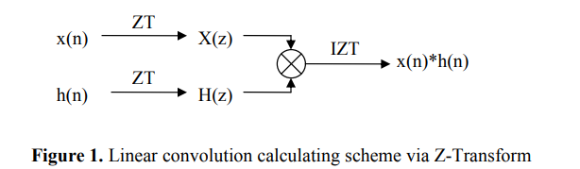

In practice, there is an efficient way to evaluate linear convolution that is using Discrete Fourier Transform (DFT). An algorithm proposed by Cooley and Tukey in 1965 to reduce the amount of computations involved in the DFT led to the explosion of using the DFT. It also led to the development of many other efficient algorithms that are known as Fast Fourier Transform (FFT) algorithms. However, there is one problem. The DFT operations result in a circular convolution instead of linear convolution as we desire. In order to use the DFT for linear convolution, we must choose the length of sequences properly. If the length of x(n) is Nx, the length of h(n) is Nh, then the length of x(n) and h(h) should be extended up to Ny = Nx + Nh -1 before doing the circular convolution between new x(n) and new h(n). Figure 2 shows the scheme of doing linear convolution using circular convolution.

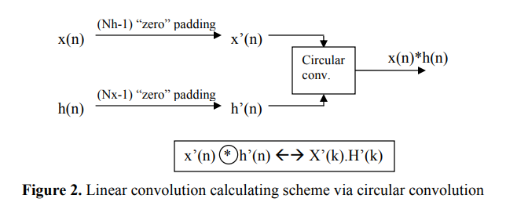

# Assignment

## **3.1. Matlab function “conv” (25%)**

The objective of this part of the lab was to find the output of some Linear Time Invariant (LTI) systems.

Let x(n) = u(n-30) – u(n-50) and have a time signal start at zero and last for 100 samples. We involved performing convolution of y(n) = x(n)*h(n) for three different systems, each characterized by a different impulse response h(n). The systems were as follows:

- the system has the impulse response h1(n) = u(n-10) – u(n-20)

- the system has the impulse response h2(n) = (0.9)nu(n)

- the system has the impulse response h3(n) = δ(n) – δ(n-1)

* **Hand calculation for convolution:**

b) h1(n) = u(n-10) – u(n-20) :

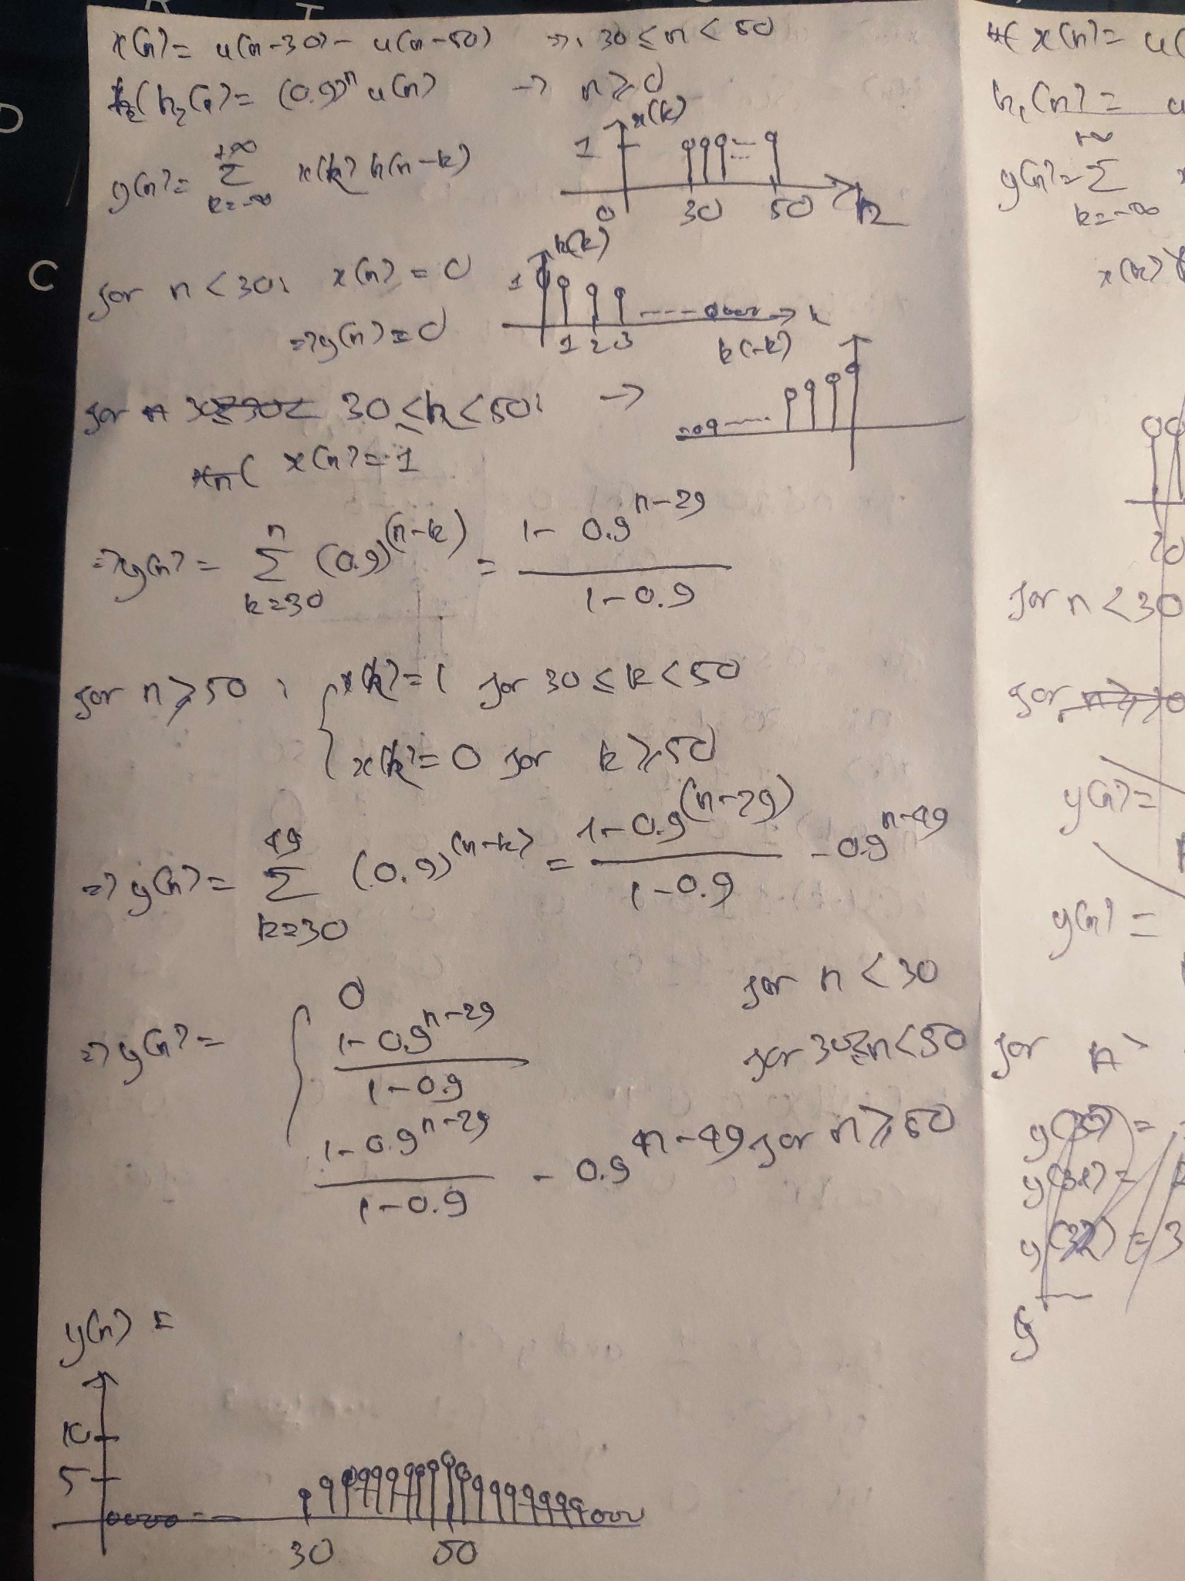

1. And c):

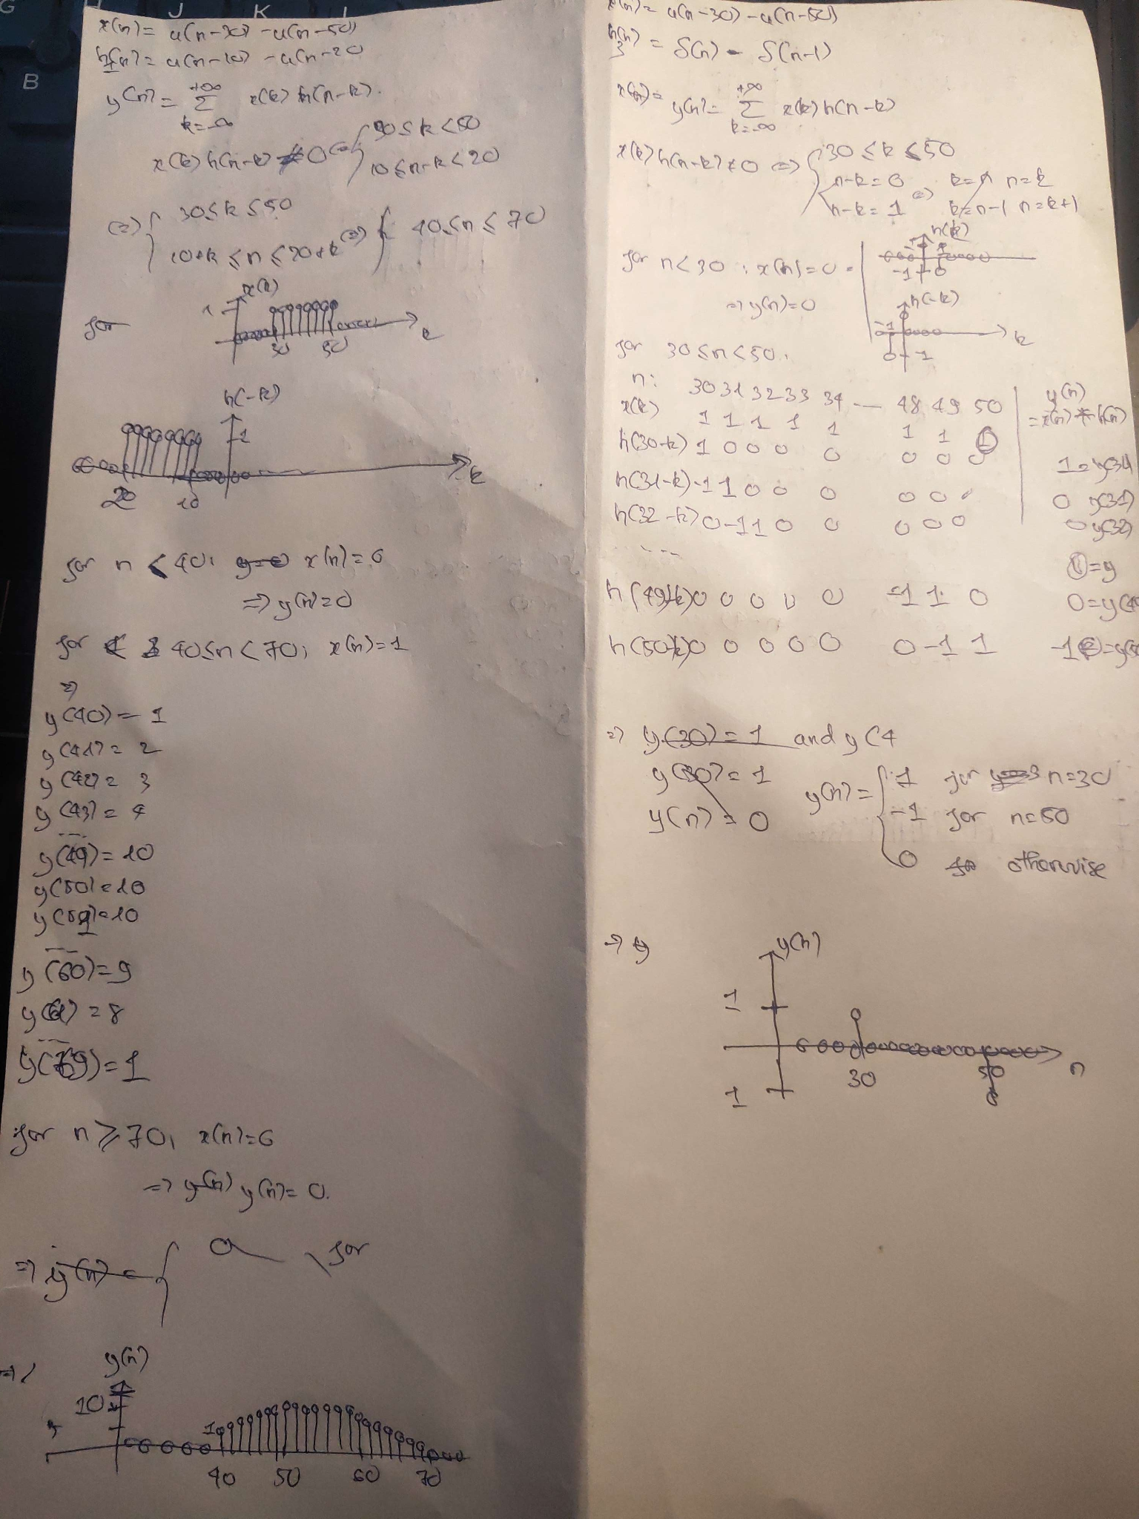

After calculation by hand, MATLAB is used in order to verify our results. Function “*conv*” which implements discrete-time convolution is used (the “*conv*” function takes two vector arguments). Since these are discrete-time signals, we should plot them using the “*stem*” command. All code of this part is in “Assignment1.m” which attack with report. Additionally, we also upgrade code to see how convolution works in file “Assignment1_Advance.m”. Fig.3 presents the convolution of three impulse responses.

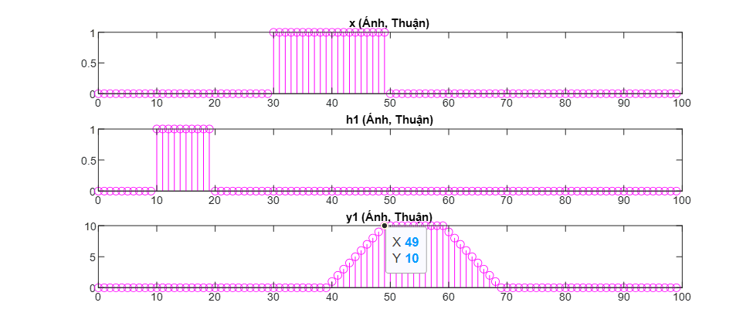

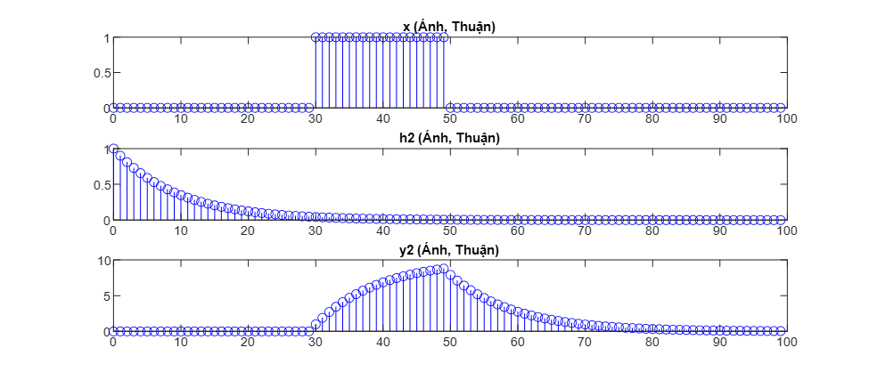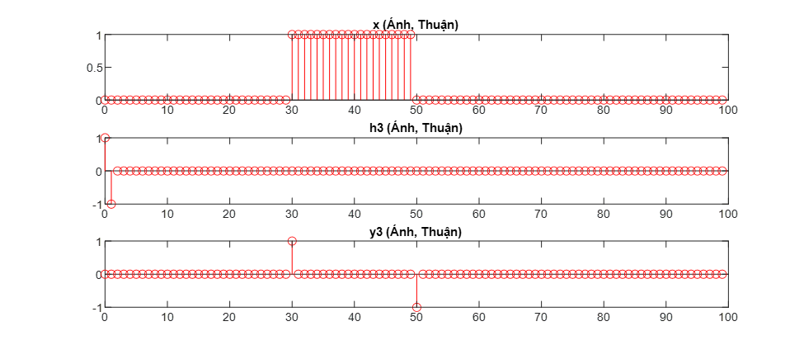

Figure 3: Convolution of x and h1, h2, and h3

Results:

The convolution signals (y1,y2, y3) are the same with our hand calculation.

## **3.2. Matrix-vector Multiplication to perform Linear Convolution (25%)**

When x(n) and h(n) are finite duration Nx and Nh, respectively, then their linear convolution (1) can also be implemented using matrix-vector multiplication. If elements of y(n) and x(n) are arranged in column vectors x and y respectively, then from (1) we obtain

$y = Hx$

where linear shifts in h(n-k) for n = 0, 1, …, Nh-1 are arranged as rows in the matrix H. This matrix has an interesting structure and is called a Toeplitz matrix. To investigate this matrix, consider the sequence

x = [1 2 3 4] and h = [3 2 1]

*- Determine the linear convolution y(n) = x(n)*h(n)*

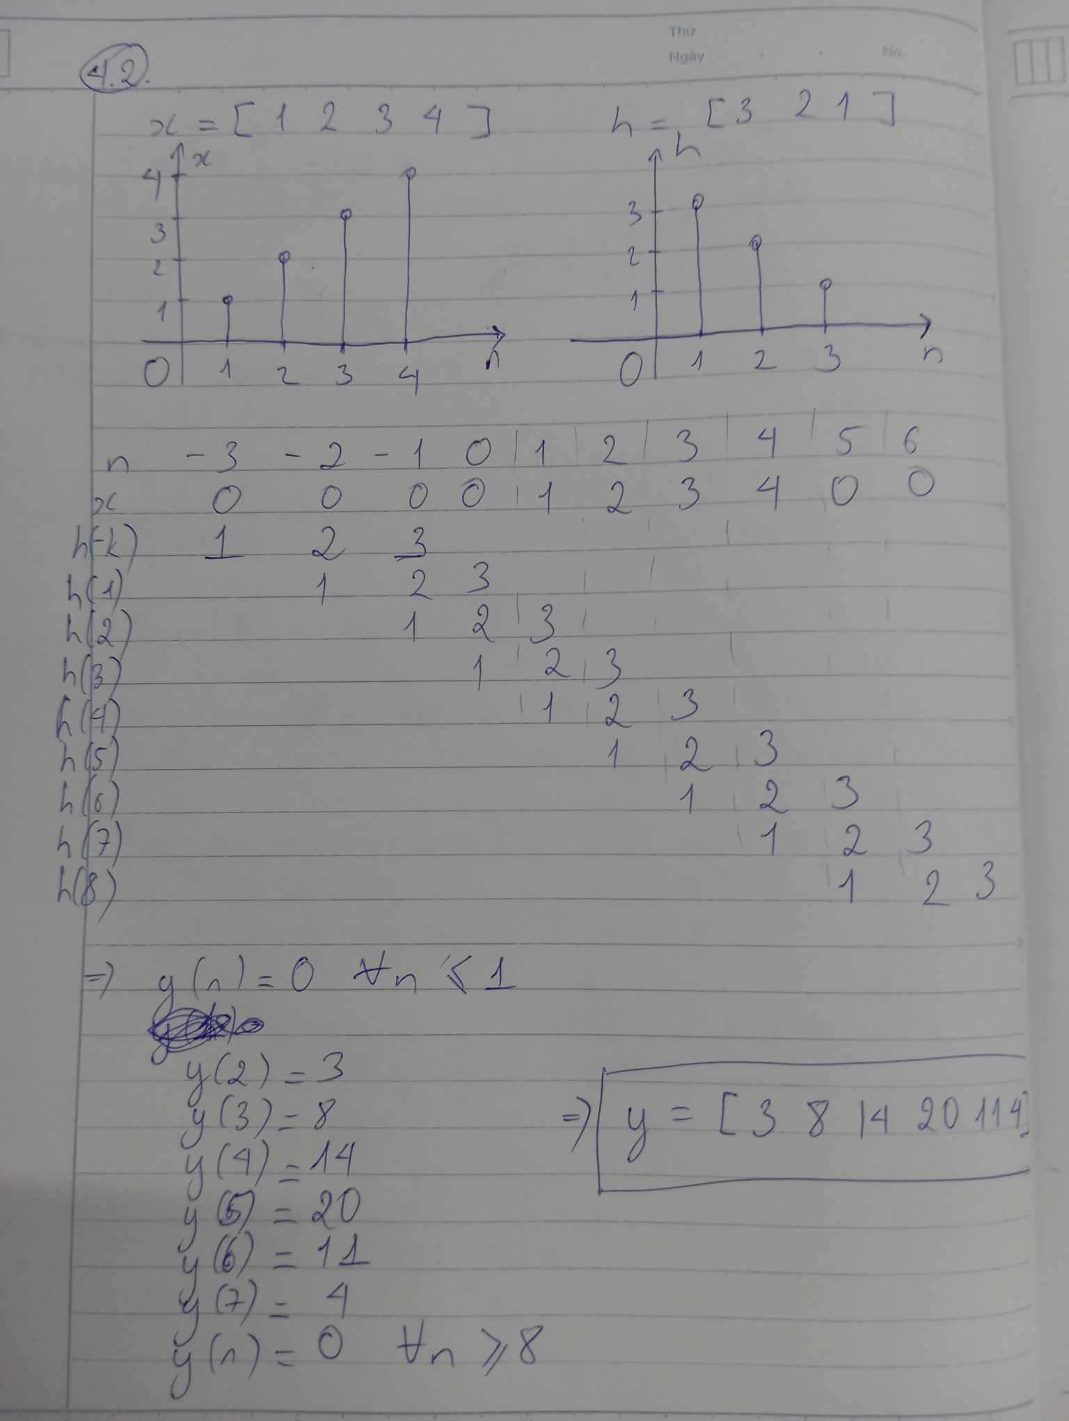

Answer: y = [3 8 14 20 11 4]

*- Express x(n) as a 4x1 column vector x and y(n) as a 6x1 column vector y. Now determine the 6x4 matrix H so that y = Hx*

From hand calculation above, we can easily obtain H

|  | 3  2  1  0  0  0 | 0  3  2  1  0  0 | 0  0  3  2  1  0 | 0  0  0  3  2  1 |  |
| --- | --- | --- | --- | --- | --- |

*H =*

*- Characterize the matrix H. Can you give the definition of a Toeplitz matrix?*

The first column of H is the sequence h extended to a length of 6 by appending zeros, and each subsequent column is obtained by shifting the sequence h to the right and appending zeros at the beginning.

The matrix H is a Toeplitz matrix because it is constructed from the sequence

h = [3 2 1] in such a way that each descending diagonal from left to right is constant

**Toeplitz matrix** is a matrix in which each descending diagonal from left to right is constant (all the elements in each descending diagonal are the same.)

*- What can you say about the first column and the first row of H?*

The first column of H is a flipped version of the h sequence, with zeros padded to match the length of the output sequence y.

The first row of H contains the first element of the h sequence as its first non-zero element, with the rest of the h sequence following it

*- Develop an alternate Matlab function to implement linear convolution.*

* **function [y,H]= conv_tp(h,x)**
* **% Length of input vectors**
* **Nh = length(h);**
* **Nx = length(x);**
* **% Extend h to be the same length as x with trailing zeros**
* **h = [h; zeros(Nx-1,1)];**
* **% Initialize H with zeros**
* **H = zeros(Nh+Nx-1, Nx);**
* **% Construct the Toeplitz matrix**
* **for i = 1:Nx**
* **H(i:end, i) = h(1:end-i+1);**
* **end**
* **% Calculate the convolution**
* **y = H*x;**
* **end**

## **3.3. Z-transform and Inverse Z-Transform (25%) ( chưa học)**

In general, by using the definition of Z-Transform, Z-Transform table, and its properties, one can determine Z-Transform of common sequences. For example, using Z-Transform table, the properties of time-shifting property and differentiation in the Z-domain, we can determine the Z-Transform of

$x(n) = (n-2)cos[\frac{π}{3}(n-2)]u(n-2)$

As below

$X(z) = \frac{0.25z^{-3} - 0.5z^{-4} + 0.0625z^{-5}}{1-z^{-1} + 0.75z^{-2} - 0.25z^{-3} + 0.0625z^{-4}}$

To check that the above X(z) is indeed the correct expression, let us use Matlab to compute the first 10 samples of the sequence x(n) corresponding to X(z)

Results:

## **3.4. Circular Convolution (25%)**

For this part, we do the same linear convolutions in problem 1 using the circular convolution. We use the Matlab functions ‘*fft’* and *‘ifft’* to do this assignment. Because in DFT, we plot the magnitude and phase of X, H1, H2, and H3.

Here is an example the code (x and H1)*:

* %% Input
* n = 0:1:99;
* x = [zeros(1,30) ones(1,70)] - [zeros(1,50) ones(1,50)];
* h1 = [zeros(1,10) ones(1,90)] - [zeros(1,20) ones(1,80)];
* %% Performing the FFT on x(n) and h(n)
* X = fft(x);
* H1 = fft(h1);
* % Multiplying the FFTs of x(n) and h(n)
* Y1 = X.*H1;
* % Performing the inverse FFT to get y(n)
* y1 = ifft(Y1);
* %% Plot
* figure()
* subplot(4,2,1)
* stem(n(1:100),abs(X(1:100)),'m') % Plot the magnitude of X
* title('Magnitude of X (Ánh, Thuận)')
* subplot(4,2,2)
* stem(n(1:100),angle(X(1:100)),'m') % Plot the phase of X
* title('Phase of X (Ánh, Thuận)')
* subplot(4,2,3)
* stem(n(1:100),abs(H1(1:100)),'m') % Plot the magnitude of H1
* title('Magnitude of H1 (Ánh, Thuận)')
* subplot(4,2,4)
* stem(n(1:100),angle(H1(1:100)),'m') % Plot the phase of H1
* title('Phase of H1 (Ánh, Thuận)')
* subplot(4,2,5)
* stem(n(1:100),abs(Y1(1:100)),'m') % Plot the magnitude of Y1
* title('Magnitude of Y1 (Ánh, Thuận)')
* subplot(4,2,6)
* stem(n(1:100),angle(Y1(1:100)),'m') % Plot the phase of Y1
* title('Phase of Y1 (Ánh, Thuận)')
* subplot(4,2,7)
* stem(n(1:100),y1(1:100),'m') % Plot the magnitude of y1
* title('y1 (Ánh, Thuận)')

\**“Assignment4.m” contain all code of this part.*

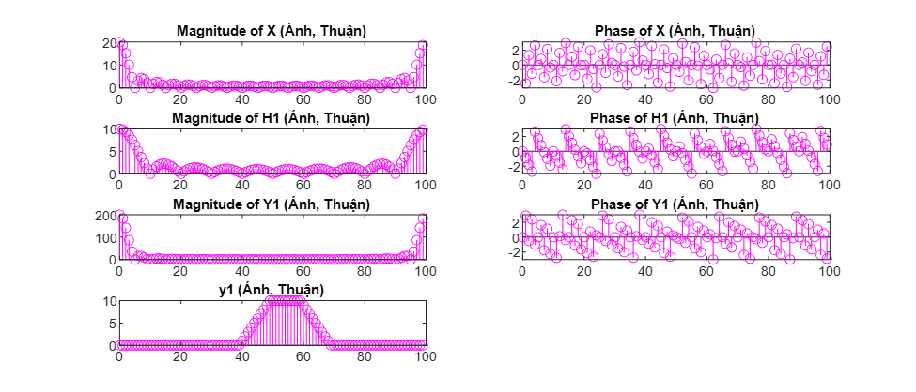

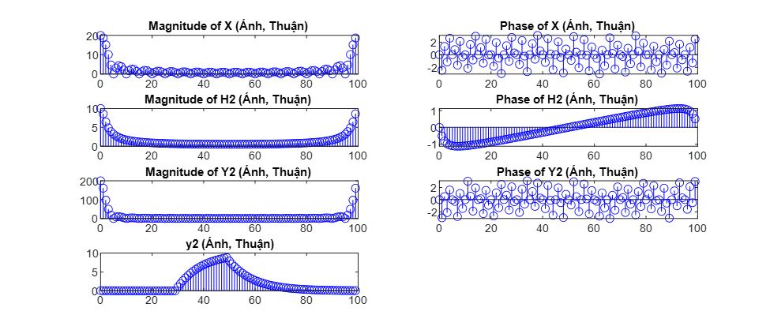

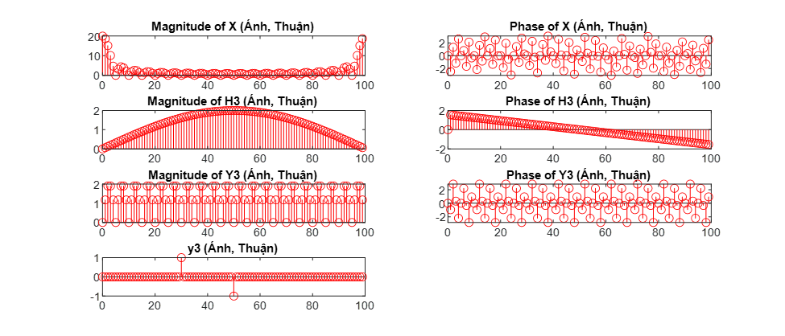

Figure 4: Convolution (circular convolution)

Results:

From fig.4, it is clear that the convolution results of this part are equal with session 3.1.

# Conclusions

In laboratory 3, we practice and learn more about linear time invariant (LTI) systems and the role of linear convolution within them.